**Stroop Data:**

In a Stroop task, participants are presented with a list of words, with each word displayed in a color of ink. The participant’s task is to say out loud the color of the ink in which the word is printed. The task has two conditions: a congruent words condition, and an incongruent words condition. In the congruent words condition, the words being displayed are color words whose names match the colors in which they are printed: for example RED, BLUE. In the incongruent words condition, the words displayed are color words whose names do not match the colors in which they are printed: for example PURPLE, ORANGE. In each case, we measure the time it takes to name the ink colors in equally-sized lists. Each participant will go through and record a time from each condition.

*Q1: Question response correctly identifies the independent and dependent variables in the experiment.*

Based on the data and the explanation, below are the dependent and independent variables.

Independent variable: Conditions of the reading that is Congruent or Incongruent.

Dependent variable: Time taken to read the word out loud is the dependent variable

*Q2a: Null and alternative hypotheses are clearly stated in words and mathematically. Symbols in the mathematical statement are defined.*

Hypotheses testing we need to do in this case is clearly to find out if there is a difference in time for reading out the words that are congruent and incongruent. So below are the statements for null and alternate hypotheses in words.

Null Hypotheses: There is no difference in time taken to read out the congruent and incongruent words.

Alternate Hypotheses: There is a difference in time taken to read out the congruent and incongruent words.

Mathematically below are the null and alternate hypotheses.

Null Hypotheses (H0):

Alternative Hypotheses (H1):

We can further this hypotheses testing to do a one sided testing claiming that time taken to read out incongruent words is more than the congruent words.

*Q2b: A statistical test is proposed which will distinguish the proposed hypotheses. Any assumptions made by the statistical test are addressed.*

Assumption: Both the congruent and incongruent data are normally distributed.

We can use a two-sided paired student T-test to verify. This is because:

* We need to address the uncertainty in sample standard error resulted from the unknown population standard deviation
* We are comparing the means of two groups that are dependent
* The same subject is involved under both conditions.

*Q3: Descriptive statistics, including at least one measure of centrality and one measure of variability, have been computed for the dataset’s groups.*

|  |  |  |
| --- | --- | --- |
|  | **Congruent** | **Incongruent** |
| Sample average | 14.05 | 22.02 |
| Sample Standard Deviation | 3.56 | 4.80 |
| n | 24 | 24 |

*Q4: One or two visualizations have been created that show off the data, including comments on what can be observed in the plot or plots.*

Below is the R code to build the graphs and the box plots to visualize the difference.

stroopdata <- read.csv('stroopdata.csv')

head(stroopdata)

library(ggplot2)

library(gridExtra)

ggplot(aes(Congruent), data = stroopdata)+

geom_histogram(breaks = c(8,12,16,20,24), color =I('black'),

fill = I('#099009'))+

ggtitle('Congruent Histogram')

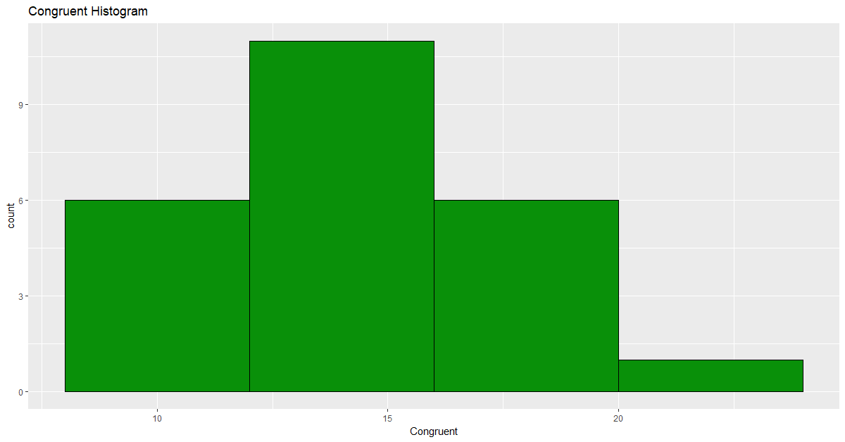

ggplot(aes(Incongruent), data = stroopdata)+

geom_histogram(breaks = c(16,20,24,28,32,36), color =I('black'),

fill = I('#099009'))+

ggtitle('Incongruent Histogram')

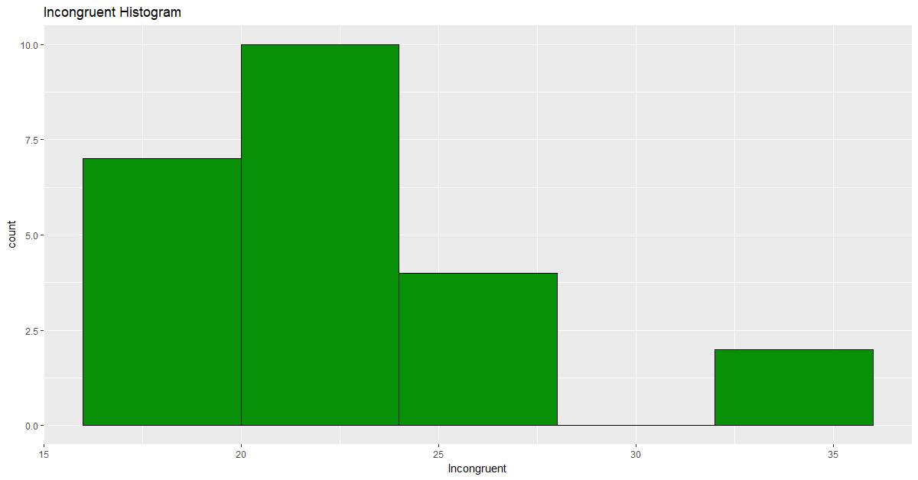

p1 <- ggplot(aes(y = Congruent, x = 1), data = stroopdata)+

geom_boxplot(fill = 'green')

p2 <- ggplot(aes(y = Incongruent, x = 1), data = stroopdata)+

geom_boxplot(fill = 'blue')

grid.arrange(p1,p2,ncol=2)

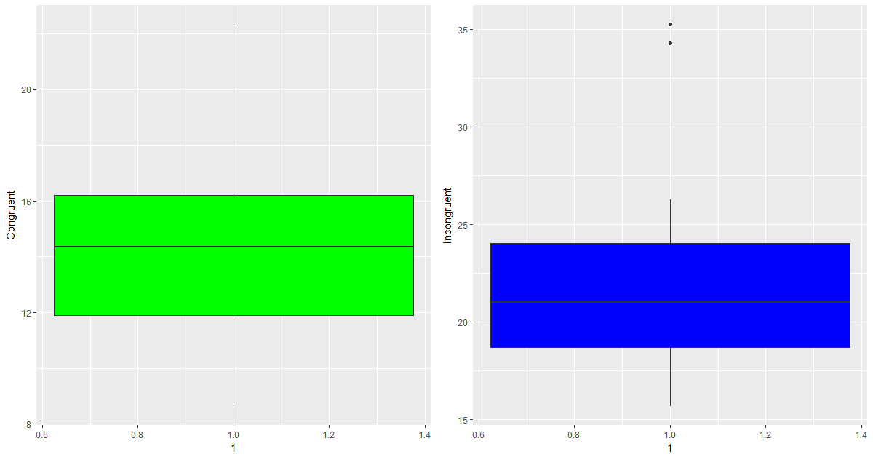

*Q5: A statistical test has been correctly performed and reported, including test statistic, p-value, and test result. The test results are interpreted in terms of the experimental task performed.*

Alpha = 0.05

Degree of freedom = 24- 1 = 23

Difference standard deviation = 4.86

T statistic = 8.02

T critical = 2.069

p-value < 0.001

Hence, the Null hypotheses is rejected and we can conclude that the time taken to read out the congruent words is not the same as the time taken to read out the incongruent words.

Attached in this document is the excel sheet with the data analysis I performed.



*Q6: Hypotheses regarding the reasons for the effect observed are presented. An extension or related experiment to the performed Stroop task is provided, that may produce similar effects.*

I believe the effort in reading out the incongruent data is not the same as reading out the congruent data. My understanding is brain processes the vision from the eyes for both reading the word and the color of the word at the same time. When brain identifies the color of the word and the word itself are same it comes out easier than when there is a conflict and brain has to do more work to read out the correct word which is to read out the word in this case.

I also believe that if we conduct an experiment to read out the color of the word without reading the word should also take different time when compared to congruent data.